**Spread of COVID-19: Adult Detention Facilities in LA County**

Authors: Maria Barriga-Beltran,Wendy Cano, Apichaya Chumsai, Haik Koyosan, Debbie Lemus, Sandra Tenorio

California State University, Los Angeles BUS 5100-93: Introduction to Business Analytics

**Abstract:** This analysis will look at the spread of COVID-19 cases within adult detention facilities in Los Angeles (LA) county. Throughout the analysis we will review the data to explore the range of positive cases in each center, see the percentage of people getting tested, explore the protocols in place where positive cases are on each side of the spectrum (high vs. low), and examine the protocols that were in place. Using the cloud visualization tool SAP Analytics Cloud (SAC) to import the data that was downloaded from the California government website and use resources and information received in class to elaborate on our investigations and findings of Covid-19 cases through adult detention facilities in LA County

**1. Introduction**

With the assistance of SAP Analytics Cloud we will use the information retrieved from the California Open Data Portal to look into Covid-19 cases in LA adult detention facilities. We will examine the information between ___(dates). This will help us see whether positive Covid-19 cases were within a similar range between institutions or if there were differences, as well as see the percentage of people getting tested throughout the specified date range. Additionally, this paper will look into the protocols in place at the institution with the most cases as well as the institution with the least cases.

**2. Work Findings**

In March of 2020, Covid-19 started spreading quickly throughout the county of Los Angeles. News and updates were consistently provided on a daily basis regarding positive cases and tests. However, updates surrounding positive cases and exams in LA County detention centers were not readily provided. We used this as an opportunity to analyze this data a little closer to get an understanding of the situation taking place in these detention centers.

**2.1 Detention Centers and Positive Cases**

There are seven adult detention centers in LA County, but there was not much data on three of them so we were unable to look into these three. The four detention centers we examined are the following: LA County Regional Detention Facility, LA Twin Towers Correctional Facility, LA Men’s Central Jail, and LA North County Correctional Facility. Between the dates of July 2020 and March 2022, the LA County Regional Detention Facility had the most cases at 487 positive cases. Their number of inmates was about 1,457 so they had a 33% positive rate. LA Twin Towers Correctional Facility has the second most positive cases at 428. They had about 2,837 inmates, so they had a 15% positive rate. LA Men’s Central Jail had a 9% positive rate with 341 positive cases and 3,811 inmates, and LA North County Correctional Facility had a 3% with 103 positive cases and 3,364 inmates. During this time frame LA county had 2.6 million positive cases with a (percentage)

Figure 1a. Total number of inmates in each facility

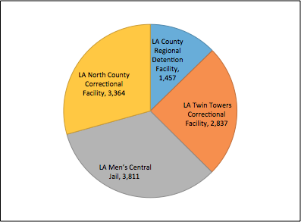

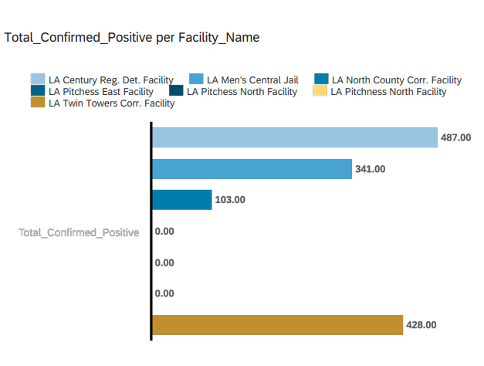

Figure 1b. Total confirmed positive cases in (July 31, 2020-March 5, 2022)

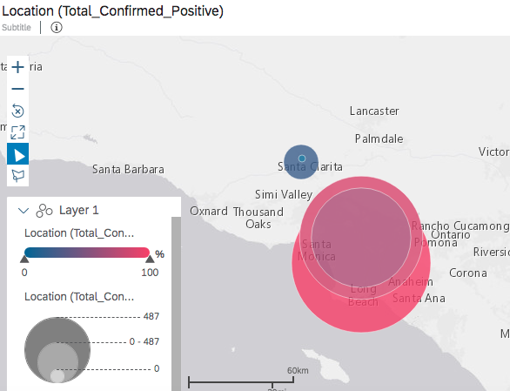

Figure 2: location of each facility in LA county with confirmed cases in (July 31, 2020-March 5, 2022)

**3. Background / Existing Work (Specifications)**

The dataset was retrieved from California Data Portal, its statewide open portal agency created to improve collaboration, expand transparency and lead to innovation. The data consist of weekly reports done by each county in California. We are mainly focusing in the Los Angeles County. The size of the data set is 43.3 KB and the following table shows specifications of what information was used.

Table 1: Data Specification

| Data Set | Size (Total) |
| --- | --- |
| Total_confirmed_positive | 43.3 KB |

**3.1 Policies put into place at facilities**

Once COVID-19 was confirmed in LA County’s adult detention centers, there were numerous policies put into place to help control the spread between inmates. If anyone had flu-like symptoms they were immediately quarantined, and if they were in a dorm setting then the entire dorm had to quarantine for 14 days to see if anyone else showed symptoms. Visitations were also put to a stop for about a year after COVID-19 infections began. Additionally, if someone showed flu-like symptoms or tested positive for COVID-19, then they couldn’t go to court. Below is a list of additional steps taken at each detention center.

1. Dedicated housing areas to become isolation and quarantine space
2. Screened incoming inmates outside before entering the Inmate Reception Center (ICR) facility
3. Inmates brought to the IRC who responded “yes’ to the screening questions or displayed symptoms were masked and isolated in the on-site Correctional Treatment Center (CTC).
4. Newly arrived arrestees who were asymptomatic, but who reported close contact with infected people, were masked and placed in quarantine if appropriate.
5. Implemented additional cleaning, sanitation, and medical isolation procedures
6. Masks were provided.

**4. Data Cleaning**

In order to properly analyze the data a csv file was downloaded from the CA open data. The first step was to add coordinates (latitude and longitude), so that we could sort the data and create visualizations by location in SAP Analytics Cloud. This would also help us to see the quantity of positive cases by location in a graph. Without the coordinates we found it difficult to view the data in a way that was helpful to us. Once this was done we were able to upload the file to SAP.

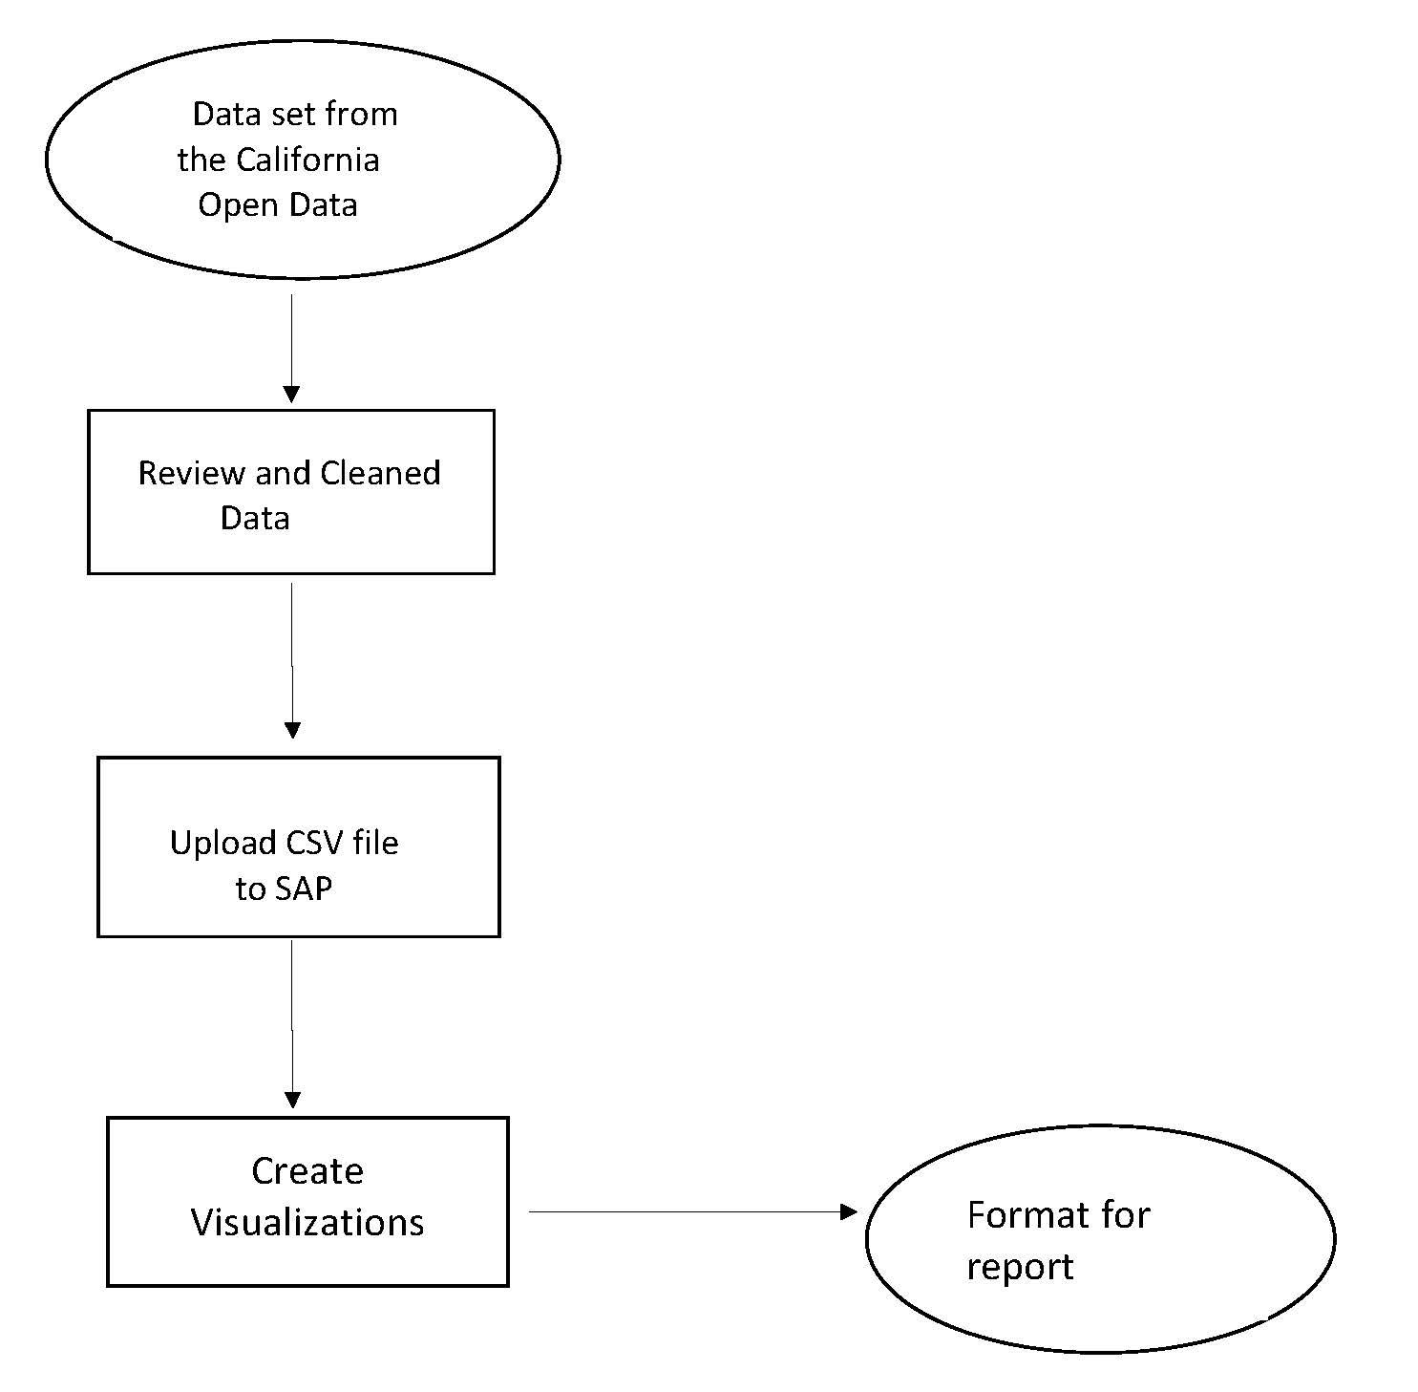

Figure 3. Implementation Flowchart

**5. Analysis and Visualization**

In trying to visualize the data, we quickly realized we were trying to analyze more data than was manageable for one project. With this discovery we decided to focus our research on positive Covid-19 cases in LA County detention centers. With this we would look at the number of inmates, positive cases, positive percentage rate, and the overall policies in place at the detention centers after Covid-19 hit. Transferring this information to a chart

Figure 4: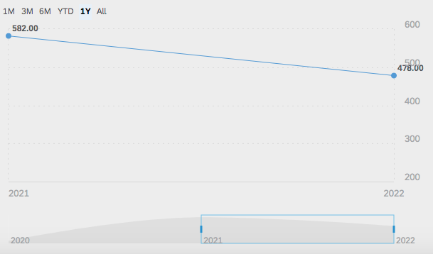

**6. Related Work**

In the midst of all the changes that took place after COVID-19 began spreadingPeople looked into how COVID-19 impacted the day to day in detention centers. There are a variety of articles were consistently provided on a daily basis regarding positive cases and tests. However, updates surrounding positive cases and exams in LA County detention centers were not readily provided. We used this as an opportunity to analyze this data a little closer to get an understanding of the situation taking place in these detention centers.

**7. Conclusion**

As we analyzed the above data and information there are a few things that were identified.

* The positive cases in these four detention centers do not provide an accurate representation of the situation compared to the county.
* An accurate representation might not have been possible since people who were showing symptoms and refused to take a COVID-19 test might have tested positive. People who were positive but didn’t take a test
* This also brings up the fact that there might not have been enough tests to distribute to each detention center.

### **References**

Spread of COVID-19: Adult Detention Facilities in LA County

This analysis will look at the spread of COVID-19 cases within adult detention facilities in LA county. Throughout the analysis we will review the data to explore the range of positive cases in each center, see the percentage of people getting tested, explore the protocols in place where positive cases are on each side of the spectrum (high vs. low), and see where resources should be distributed.

Data sets:

California Open Data Portal:

[https://data.ca.gov/group/covid-19?page=1](https://nam10.safelinks.protection.outlook.com/?url=https%3A%2F%2Fdata.ca.gov%2Fgroup%2Fcovid-19%3Fpage%3D1&data=04%7C01%7Cdlemus22%40calstatela.edu%7C7b62b360150d453795d108d9fcc50b16%7Cce8a2002448f4f5882b1d86f73e3afdd%7C0%7C0%7C637818745500643739%7CUnknown%7CTWFpbGZsb3d8eyJWIjoiMC4wLjAwMDAiLCJQIjoiV2luMzIiLCJBTiI6Ik1haWwiLCJXVCI6Mn0%3D%7C3000&sdata=2n0dR4fP4weabXrEScEPDo6FUPLlubFiytReys2ygEo%3D&reserved=0)

COVID-19 in Local Adult Detention Facilities

[https://data.ca.gov/dataset/covid-19-in-local-adult-detention-facilities](https://nam10.safelinks.protection.outlook.com/?url=https%3A%2F%2Fdata.ca.gov%2Fdataset%2Fcovid-19-in-local-adult-detention-facilities&data=04%7C01%7Cdlemus22%40calstatela.edu%7C7b62b360150d453795d108d9fcc50b16%7Cce8a2002448f4f5882b1d86f73e3afdd%7C0%7C0%7C637818745500643739%7CUnknown%7CTWFpbGZsb3d8eyJWIjoiMC4wLjAwMDAiLCJQIjoiV2luMzIiLCJBTiI6Ik1haWwiLCJXVCI6Mn0%3D%7C3000&sdata=Ff4cvCVfxbHr18PGbFGVp%2FF6bfecoBw26F4hXIGkG%2BM%3D&reserved=0)

COVID-19 in Local Juvenile Detention Facilities

[https://data.ca.gov/dataset/covid-19-in-local-juvenile-detention-facilities](https://nam10.safelinks.protection.outlook.com/?url=https%3A%2F%2Fdata.ca.gov%2Fdataset%2Fcovid-19-in-local-juvenile-detention-facilities&data=04%7C01%7Cdlemus22%40calstatela.edu%7C7b62b360150d453795d108d9fcc50b16%7Cce8a2002448f4f5882b1d86f73e3afdd%7C0%7C0%7C637818745500643739%7CUnknown%7CTWFpbGZsb3d8eyJWIjoiMC4wLjAwMDAiLCJQIjoiV2luMzIiLCJBTiI6Ik1haWwiLCJXVCI6Mn0%3D%7C3000&sdata=SPUbQhh1L%2Bf51LNKaqKGOsXH1cEg5f6FfbQYRH3xQZo%3D&reserved=0)

<http://www.laalmanac.com/crime/cr25b.php>

Covid Prison Project

<https://github.com/healthandjustice/covid-prison-project>

<https://covidprisonproject.com/data/national-overview/>

Los angeles County Coronavirus updates

<https://lasd.org/covid19updates/>

http://dashboard.publichealth.lacounty.gov/covid19_surveillance_dashboard/

RELATED WORK

<https://theintercept.com/2021/03/02/covid-jails-los-angeles-court-dates/>

<https://www.cbs8.com/article/news/local/california/covid-cases-triple-california-juvenile-prisons/509-96ee5dbe-8173-48cc-8b1d-d622e8013da4>

[https://data.ca.gov/dataset/covid-19-in-local-adult-detention-facilities](https://nam10.safelinks.protection.outlook.com/?url=https%3A%2F%2Fdata.ca.gov%2Fdataset%2Fcovid-19-in-local-adult-detention-facilities&data=04%7C01%7Cdlemus22%40calstatela.edu%7C7b62b360150d453795d108d9fcc50b16%7Cce8a2002448f4f5882b1d86f73e3afdd%7C0%7C0%7C637818745500643739%7CUnknown%7CTWFpbGZsb3d8eyJWIjoiMC4wLjAwMDAiLCJQIjoiV2luMzIiLCJBTiI6Ik1haWwiLCJXVCI6Mn0%3D%7C3000&sdata=Ff4cvCVfxbHr18PGbFGVp%2FF6bfecoBw26F4hXIGkG%2BM%3D&reserved=0)

* Look at counties
* Which prisons have higher rates?
  + How was this approached?
  + Population
  + How county handled it as a whole and how it trickled into each system
* Processes and protocols for each category
* 3/16 :
  + Positive cases
  + Population in each prison (pull percentage and ratios)
  + Only looking at LA county
  + Analysis of cases vs. dates
  + Compare how many people got tested and how many tested positive (ratios)

**Write up**: Maria, Wendy, Debbie

NOTES FOR 3/21 (did the other 4 not test?)

**Policies put into place at facilities**

1. Dedicated housing areas to become isolation and quarantine space
2. Screened incoming inmates outside before entering the Inmate Reception Center (ICR) facility
3. Inmates brought to the IRC who responded “yes’ to the screening questions or displayed symptoms were masked and isolated in the on-site Correctional Treatment Center (CTC).
4. Newly arrived arrestees who were asymptomatic, but who reported close contact with infected people, were masked and placed in quarantine if appropriate.
5. Implemented additional cleaning, sanitation, and medical isolation procedures
6. Masks were provided.

4 Facilities

* LA County Regional Detention Facility Most cases
  + # of inmates: 1,457 (about 33% tested positive)
* LA Twin Towers Correctional Facility (2nd Most)
  + # of inmates: 2,837 (about 15% tested positive)
* LA Men’s Central Jail (3rd Most)
  + # of inmates: 3811 (about 9% tested positive)
* LA North County Correctional Facility (4th most)
  + # of inmates: 3,364 (about 3% tested positive)
  + (pull percentages of positive cases)

Note: there were inmates were actively trying to get infected.

**SAP (graphs/models)**: Haik, Sandra

* Bubble graphs (adult)
* Pie chart (total positive cases vs. total population)
* Horizontal bar graph comparing the different locations positive cases in a specific date range
* Regression / Time series (for each group?)
* Graph comparing positive cases vs. people who tested.

**SAP Tutorial**: Haik, Sandra

**Powerpoint**: Apichaya

* Area vs population

**Tutorial resources**